**LIVE PROJECT SUBMITTED IN PARTIAL FULFILLMENT OF THE REQUIREMENT FOR THE CERTIFICATE OF**

**“NETWORK SURVEY & IMPLEMENTATION”**

**SUBMITTED BY**

**SADIQUJJAMAN**

**ASAR MOHAMMAD**

**SUJOY HALDER**

**MD DANISH**

**AT**

**CENTRAL TOOL ROOM AND TRAINING CENTRE**

**MSME TOOL ROOM, KOLKATA**



**SESSION-20th JANUARY, 2020 – 12th FEBRUARY, 2021**

**UNDER THE SUPERVISION OF**

**MR. SAMIR SAHOO**

~~~~

**MSME TOOL ROOM-KOLKATA**

**(Central Tool Room & Training Centre)**

AN ISO 9001:2015 CERTIFIED

Under Ministry of Micro, Small & Medium Enterprises

Government of India

**CERTIFICATE**

This is to certify that they have undergone the live project on

**“NETWORK SURVEY & IMPLEMENTATION”**

and prepared this project report by virtue of his Diligence and Self-effort.

They have successfully completed every aspect of this project with a lot of sincerity while abiding with the rules of the institution.

We wish them all for his bright future.

**Project Coordinator Senior Manager**

**(HOD, Training)**

***INDEX***

1. **ACKNOWLEDGEMENT**
2. **INTRODUCTION**
3. **FTP**
4. **TFTP**
5. **DNS**
6. **CLOUD FRAME RELAY**
7. **ROUTER & SWITCH**
8. **BIBLIOGRAPHY**
9. ***ACKNOWLEDGEMENT***
10. Patience and perseverance is the part and parcel to make fulfill any desired motto successful. Not only these two Indispensable characters but also kind operation and zestful help is always required with which one can be able to reach his ultimate goal after passing through several incidents.
11. Likewise we do have the pleasure to expose that we have completed our industrial training project on "Cisco Certified Network Associates(CCNA)". So, at the very outset we deeply feel like expressing my indebtedness and gratitude to all concerned, unless who's help, valued suggestions and guidance and moral boosting, the presence of work of ours would not have been possible.
12. We express our sincere thanks from the bottom of the heart to Mr. M Rama Rao (Training-in-charge) who became the source of inspiration to us in completion of the project.
13. We are further thankful to our training faculties Mr. Samir Sahoo and Mr. Mukta Pradhan who's valuable and priceless suggestions helped us at various stages of this project.

***2.INTRODUCTION***

This project is on Network Survey & Implementation for smart campus through which we are trying to make our campus fully smart and we can remotely access any device from within or outside the network through which we are also trying to implement **Internet Of Things (IOT)** so that we can make our campus a smart one the main motive of this project was to use the technology in such a way the we can get best use of it we have used many updated network devices and protocols such as HSRP,VTP,VPN…ETC.I would like you to go through our project and get the best technology in hand.

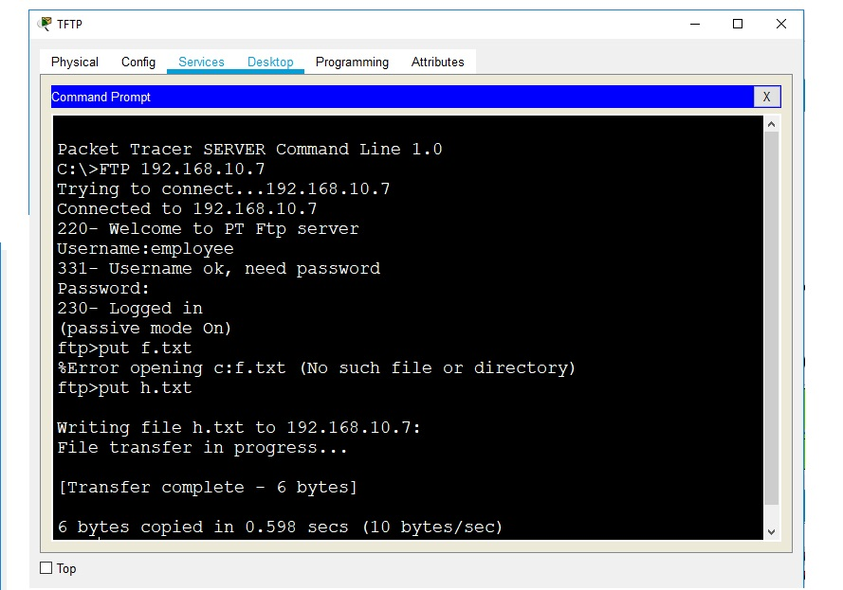***3.FTP***

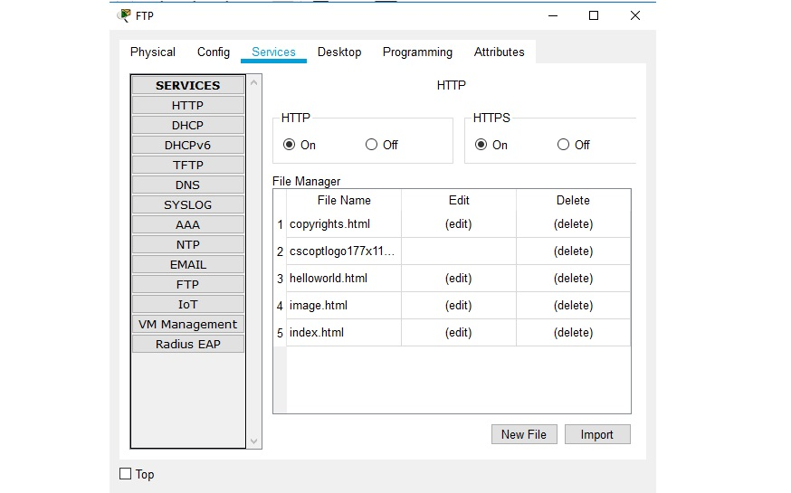

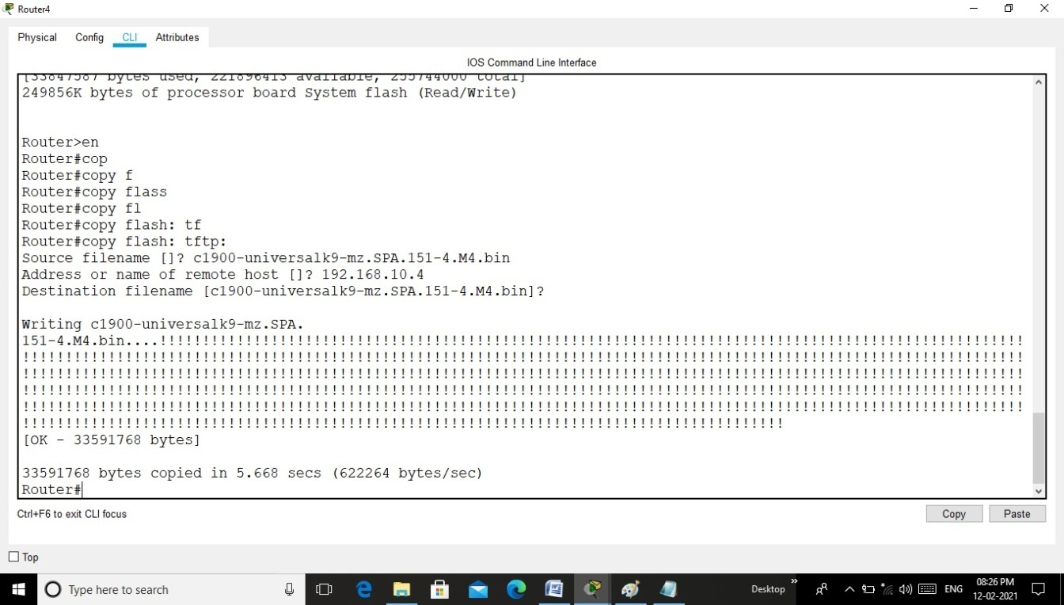***4.TFTP***

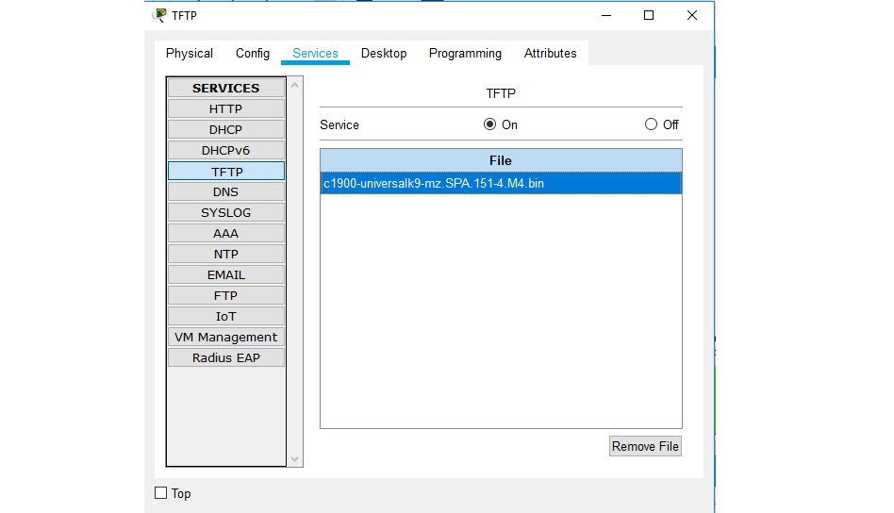

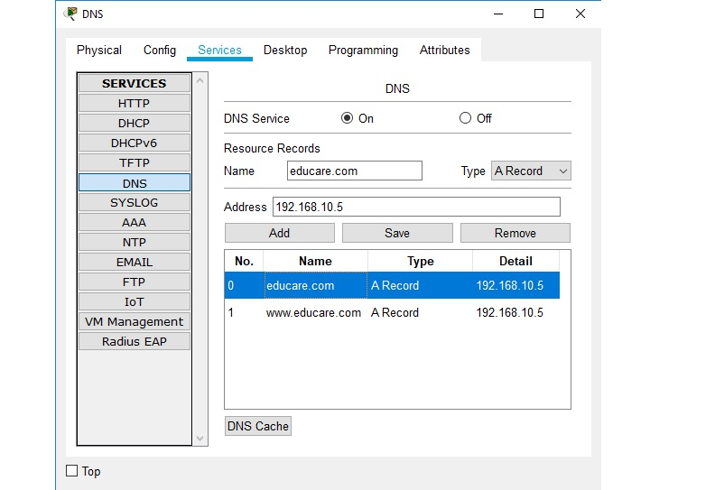***5.DNS***

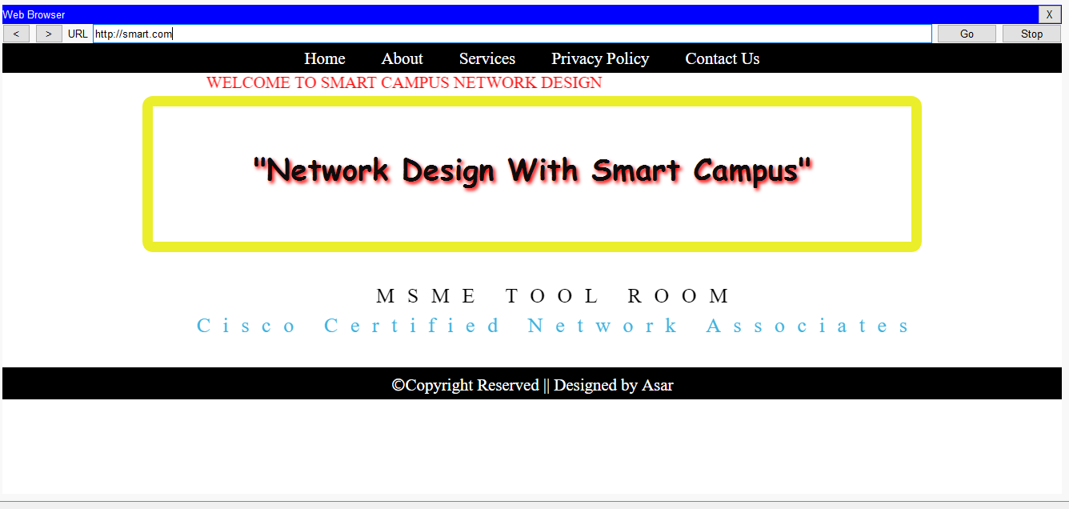

***BIBLIOGRAPHY***

This project has been done under the supervision of our beloved teacher Mr Samir Sahoo sir & Mr Mukta Pradhan.

We got the guidance from online website in name [www.netacad.com](http://www.netacad.com) and [www.itexams.net](http://www.itexams.net) .